Updated November 2020

Northbourne Church of ENGLAND pRIMARY SCHOOL
Calculation Policy


Maths Mastery
Mastering maths means pupils of all ages acquiring a deep, long-term, secure and adaptable understanding of the subject. The phrase ‘teaching for mastery’ describes the elements of classroom practice and school organisation that combine to give pupils the best chances of mastering maths. Achieving mastery means acquiring a solid enough understanding of the maths that’s been taught to enable pupils to move on to more advanced material. (NCETM) As a school, we use the White Rose Maths schemes of learning as a basis for Maths planning. Teachers use the year group modules for their particular year group and they will not move onto a higher year group’s scheme of work. These modules support teaching for mastery and encourage the children to use concrete materials and pictorial representations, developing their fluency, reasoning and problem solving skills in mathematical concepts.

Mathematical Language
The 2014 National Curriculum clearly states the importance of using the correct mathematical language with children and children using that language in their learning. When teaching from this policy, it is essential that the appropriate and precise mathematical language is used and explained carefully. Children are expected to use correct and appropriate mathematical vocabulary as they progress through the school.

How to use the policy
This policy has been adapted from the White Rose Maths Calculation Policy. It has been set out as a progression of mathematical skills rather than into year group phases. Teachers will decide when consolidation of skills is required or when to move onto the next concept. It is vitally important however that the emphasis for the children is to broaden and deepen their knowledge rather than to accelerate through the concepts. In order to do this, children will tackle a variety of problems, developing their reasoning and problem solving skills with increasing challenges, within their year group scheme of work. Progression should be considered next to the ‘Ready to Progress Criteria’ provided by the Department for Education: https://assets.publishing.service.gov.uk/government/uploads/system/uploads/attachment_data/file/897806/Maths_guidance_KS_1_and_2.pdf

Addition
Objective and Strategies | Concrete | Pictorial | Abstract
Combining two parts to make a whole: part-whole model | 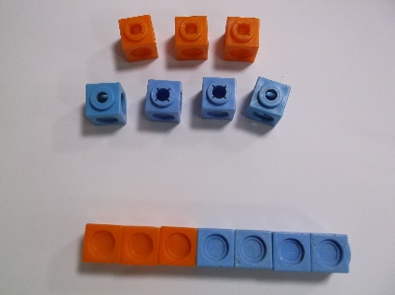  Use resources (e.g. cubes, cars, teddies, blocks) to add two numbers together as a group or in a bar. | 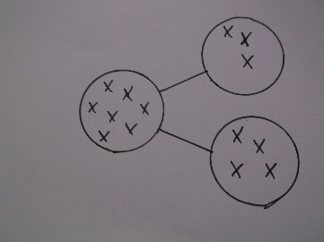  Represent the objects using pictures to add two numbers together as a group or in a bar. Dots or crosses could be used in a part-whole model. | Use a part-part whole diagram to move onto the abstract.  4 + 3 = 7  Four is a part, 3 is a part and the whole is seven.  4  7  3
Starting at the bigger number and counting on | 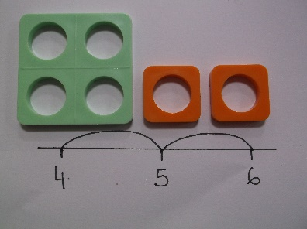  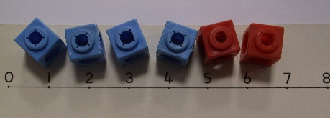  Start with the larger number then count on 1 by 1 to find the answer. | Start at the larger number on the number line or bar model and count on in ones or in one jump to find the answer.  4 + 2 = 6  3 4 5 6  4  ? | The abstract number line:  What is 2 more than 4?  What is the sum of 2 and 4?  What is the total of 4 and 2?  4 + 2  4 5 6
Objective and Strategies | Concrete | Pictorial | Abstract
Regrouping to make 10 | 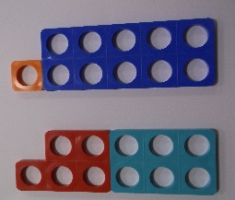  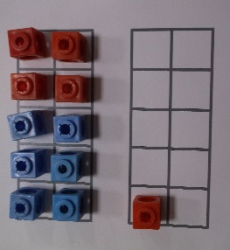  Start with the larger number and use the smaller number to make 10 – e.g use ten frames and cubes or Numicon. | Draw the ten frame, use pictures or a number line. Regroup or partition the smaller number to make 10.  6 + 5 = 11  4 1 | If I am at six, how many more do I need to make 10? How many more do I add now?  6 + 5 = 11 (6 + 4 = 10 + 1 = 11)  6 + = 11  6 + 5 = 5 +  = 6 + 5
Adding three single digits | Make 10 with two of the digits (if possible) then add the third digit.  4 + 7 + 6 = 17  Put 4 and 6 together to make 10. Add on 7.  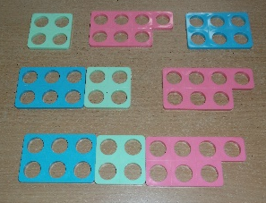 | Add together three groups of objects. Draw a picture to recombine the groups to make 10.  4 + 7 + 6  6 + 4 = 10 then + 7  + +  + | Combine the two numbers that make 10 and add the remainder.  4 + 7 + 6 = 10 + 7  10  = 17
Objective and Strategies | Concrete | Pictorial | Abstract
Column method with base 10, no regrouping | Add together the ones first, then add the tens. Use Base 10 and then place value counters.  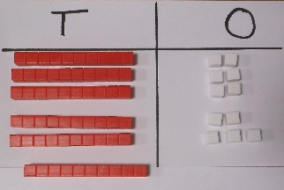  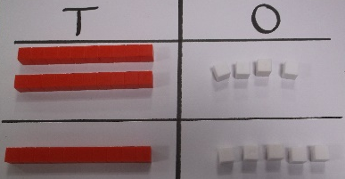  24 + 15 | Represent Base 10 e.g. as lines for tens and dots/crosses for ones.  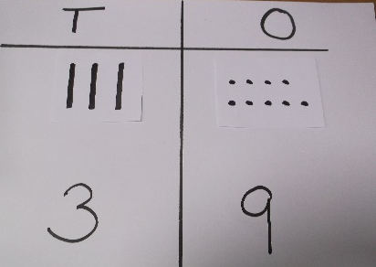  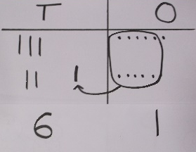 | 24 + 15  4 + 5 = 9  20 + 10 = 30  30 + 9 = 39  2 4  + 1 5  Formal method: 3 9
Column method with base 10, with regrouping  Column Method with place value counters | Make both numbers with Base ten or place value counters.  36 + 25  Use place value counters, showing exchange.  243 + 368  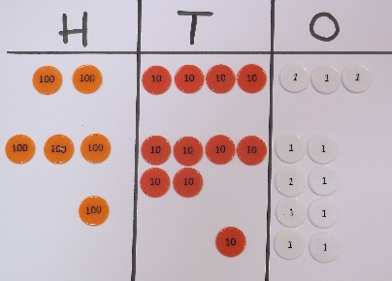 | Represent the Base 10 in a place value chart.  Represent the counters in a place value chart, circling when to make an exchange.  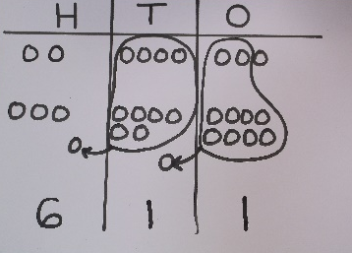 | Start by partitioning the numbers, before moving on to clearly show the exchange below the addition:  30 + 6 36  20 + 5 + 25  50 + 11 = 61 61  1  Formal method:  2 4 3  + 3 6 8  6 1 1  1 1  This will lead to an understanding of adding any number, however large and including decimals.
Subtraction

Objective and Strategies | Concrete | Pictorial | Abstract
Taking away ones | Use physical objects, counters, cubes, Numicon etc. to show how objects can be taken away.  4 – 3 = 1  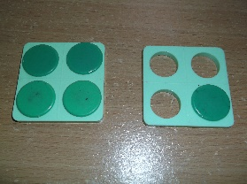 | Cross out drawn objects to show what has been taken away.   | 4 – 3 = 1  = 4 - 3  4  3 ?  4  3  ?
Counting back | Start with the larger number and count back.  9 – 4 = 5  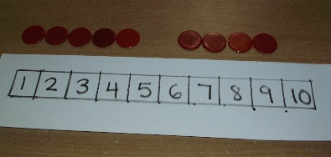  D  D  D  Subtraction | Count back on a number line or track. Make a pictorial representation.  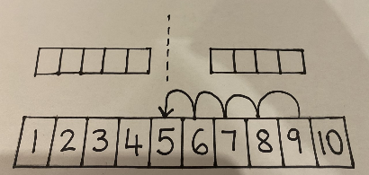  9 – 4 = 5 | “Put 9 in your head, count back 4. What number are you at? Use a number line to help – or your fingers!”

Objective and Strategies | Concrete | Pictorial | Abstract
Find the difference | Use cubes, Numicon or other objects to find the difference.  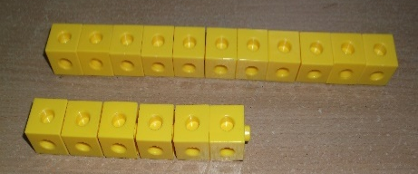  Calculate the difference between 11 and 6  ? | Draw cubes or other objects used and/or use bars to find the difference.  ?  11  6  ? | Find the difference between 11 and 6.  11 – 6, the difference is  Rosie has 11 sandwiches, Sophie has 6 sandwiches. Find the difference between the number of sandwiches.
Part-whole model | Link to addition – use the part whole model to help explain the inverse between addition and subtraction.  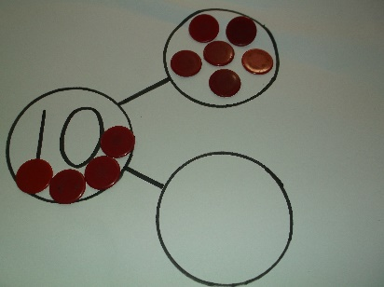  10 – 6 = | Use a pictorial representation to show the part whole model | Move to using numbers within the part whole model.  6  10  4  10 – 6 = 4  10 – 4 = 6

Objective and Strategies | Concrete | Pictorial | Abstract
Make 10 | Using a ten frame  14 – 5  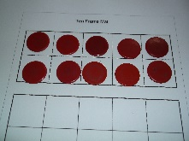  - - 4  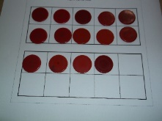  - 1  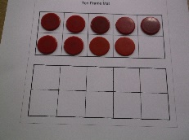 | Present the ten frame pictorially and discuss - start at 14, take away 4 to reach 10, then take away the remaining 1. They have taken away 5 altogether. | Show how to make 10 by partitioning:  14 - 5 = 9  4 1  14 – 4 = 10  10 – 1 = 9
  O | O | O | O | O
  O | O | O | O | O
  O | O | O | O
Column method with base 10 without regrouping | Use base 10  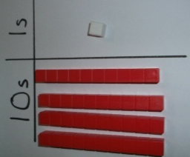  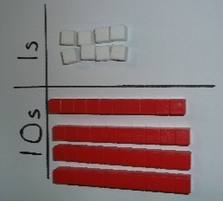  48 – 7 | 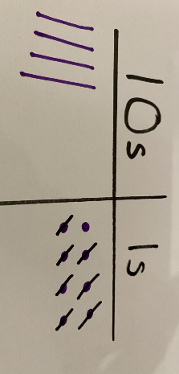  Represent the base 10 pictorially or with place value counters. | This will lead to a clear, written, column subtraction.  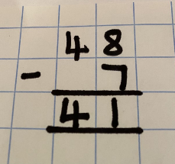
Objective and Strategies | Concrete | Pictorial | Abstract
Column method with regrouping | Use Base 10 and start with one exchange before moving onto subtractions with two or more exchanges.  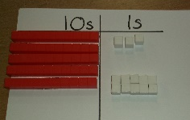  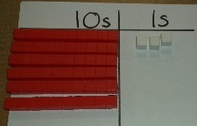  63 - 27  Make the larger number first, then exchange 1 ten for 10 ones. Now complete the subtraction.  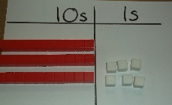 | Represent the Base 10 pictorially, showing the exchange.  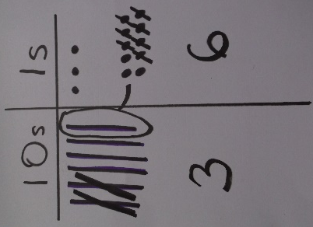 | Formal Column method. Children must understand that when they have exchanged the 10 they still have 63 because 63 = 50 + 13.  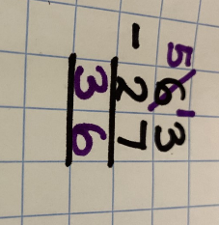
Column method using place value counters | 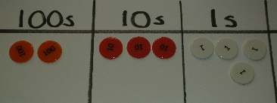  234 – 88  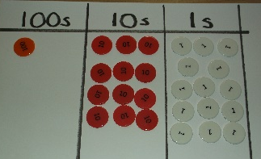  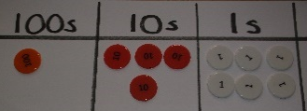  146 | Represent the place value counters pictorially, remembering to show what has been exchanged.  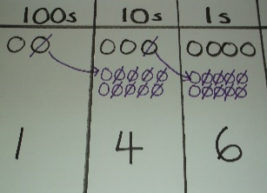 | Formal column method.  ¹2 ¹²3 ¹4  - 8 8  1 4 6  This will lead to an understanding of subtracting any number, however large and including decimals.
Multiplication
Objective and Strategies | Concrete | Pictorial | Abstract
Recognising and making equal groups | Use different objects to make equal groups.  3 x 2  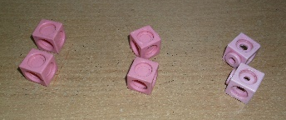 | 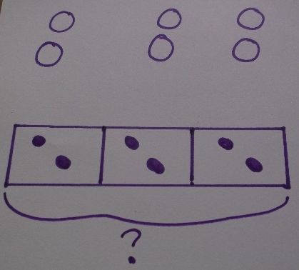  Represent the practical resource as a picture. | Write the equal groups as a number sentence  3 x 2 = 6  2 x 3 = 6  6 = 3 x 2
Doubling | Use practical activities to show how to double a number.  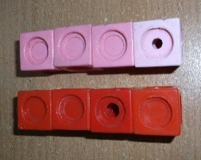  Double 4 = 8  4 x 2 = 8 | Draw pictures to show how to double a number.  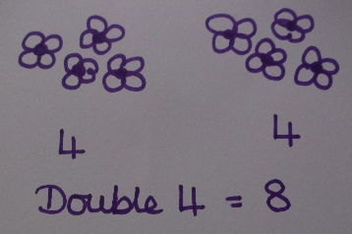 | Partition a number then double each part before recombining it back together.  12  10 2  X 2 x 2  20 4  Double 12 is 20 + 4  Double 12 = 24
Objective and Strategies | Concrete | Pictorial | Abstract
Counting in multiples | Count in multiples with objects in equal groups  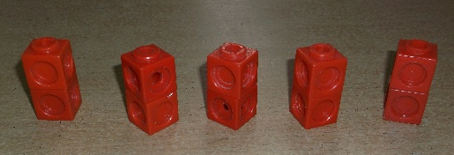  2 4 6 8 10 | Use a number line or pictures to continue counting in multiples  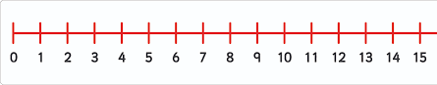 | Count in multiples of a number aloud and write sequences with multiples of numbers.  2, 4, 6, 8, 10  5, 10, 15, 20, 25, 30
Repeated addition | Use different objects to add equal groups  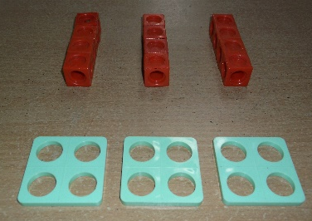  4 + 4 + 4 | Represent the practical resources as a picture and use a bar model.  4 + 4 + 4 | Write addition sentences to describe the objects and pictures.  4 + 4 + 4 = 12  3 x 4 = 12  4 x 3 = 12
Arrays to show commutativity | Create arrays to show multiplication sentences  2 x 5 = 5 x 2  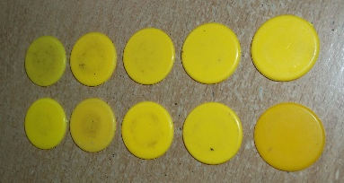 | Represent the arrays pictorially  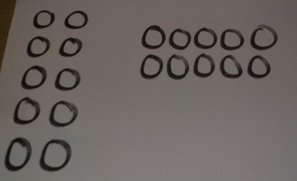 | Use an array to write a range of calculations  10 = 2 x 5  2 x 5 = 10  5 x 2 = 10  2 + 2 + 2 + 2 + 2 = 10  10 = 5 + 5

Objective and Strategies | Concrete | Pictorial | Abstract
Grid Method | Show the link first with arrays to introduce the grid method.  13 x 4  4 rows of 10 and 4 rows of 3  Move onto Base 10  4 rows of 13 | 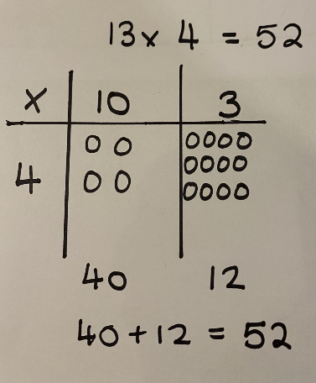  Represent the work pictorially, drawing the counters or just circles in different columns to show thinking. | Start with multiplying one digit numbers and showing the clear addition alongside.  13 x 4  40 + 12 = 52  Moving forward, multiply 2 digits by 2 digits or more, showing the different rows in the grid.  18 x 13  100 + 80 = 180  30 + 24 = 54  180 + 54 = 234
  X | 10 | 3
  4 | 40 | 12
  X | 10 | 8
  10 | 100 | 80
  3 | 30 | 24
Objective and Strategies | Concrete | Pictorial | Abstract
Column multiplication | Use place value counters initially.  Important to always multiply from the smallest place value column.  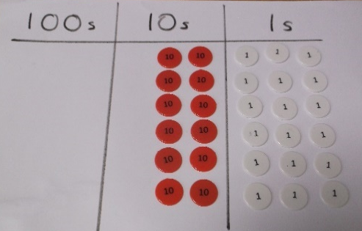  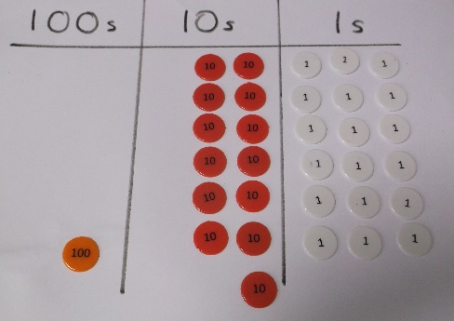  23 x 6  1 3 8 | Represent the counters pictorially and use a bar model  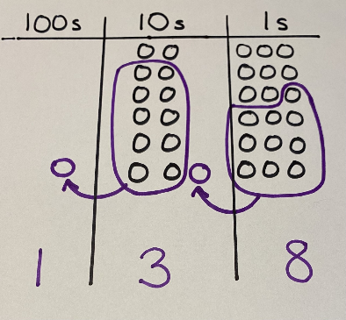  23 x 6  23 23 23 23 23 23  ? | Children record what they are doing to show understanding and move to the formal column method  3 x 23 3 x 20 = 60  3 x 3 = 9  20 3 60 + 9 = 69  23  X 3  69  6 x 23 =  23  X 6  138  1 1
Long Multiplication | When children start to multiply 3 digits by 2 digits and 4 digits by 2 digits, they should be confident with the abstract. They should start with the grid method first (see above) and then move onto the formal method of long multiplication.  To complete 124 x 26, children will:  Get 744 by solving 124 x 6  Get 2480 by solving 124 x 20 |  | 1 2 4  X 2 6  7 4 4  2 4¹8²0  3 2 2 4  1 1

Division
Objective and Strategies | Concrete | Pictorial | Abstract
Sharing objects into groups | Share into groups using a range of objects  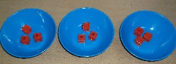  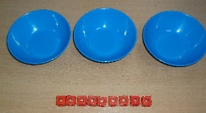  9 ÷ 3  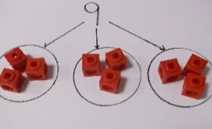 | Represent the sharing pictorially | 9 ÷ 3 = 3  9  Share 9 biscuits between 3 people.
  3 | 3 | 3
Division as grouping | Divide quantities into equal groups  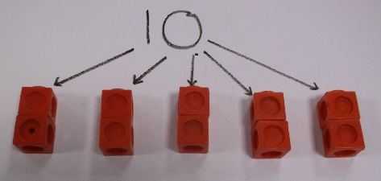  10 ÷ 5 | Use a number line to show jumps in groups. The number of jumps equals the number of groups.  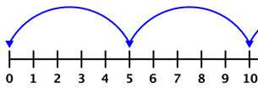  5 5  Use a bar model and split it into the number of groups you are dividing by to work out how many would be in each group.  10  ?  10 ÷ 5 = ? 5 x ? = 10 | 10 ÷ 5 = 2  Divide 10 into 5 equal groups. How many are in each group?
Objective and Strategies | Concrete | Pictorial | Abstract
Division within arrays | 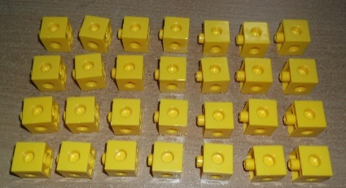  Link division to multiplication by creating arrays and thinking about the number sentences that can be created.  28 ÷ 4 = 7 7 x 4 = 28  28 ÷ 7 = 4 4 x 7 = 28 |   Draw an array and use lines to split the array into groups to make multiplication and division sentences. | Find the inverse of multiplication and division sentences by creating four linking number sentences.  7 x 4 = 28  4 x 7 = 28  28 ÷ 7 = 4  28 ÷ 4 = 7
Repeated subtraction | Use counters above a ruler or number line  6 ÷ 2  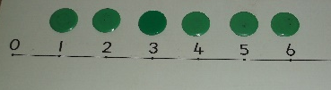  3 groups of 2 | 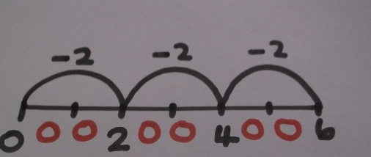  Represent repeated subtraction pictorially | Use a number line to represent the equal groups that have been subtracted.  6 ÷ 2 = 3  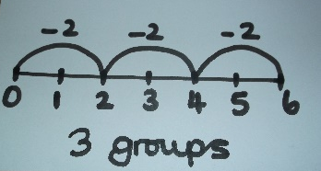
Objective and Strategies | Concrete | Pictorial | Abstract
Division with a remainder | Divide objects between groups and see how many are left over.    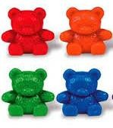  14 ÷ 3 | 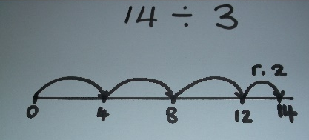  Use a number line to see how many groups you make and how many more you need to jump to find a remainder.  Draw dots and group them or a bar model to divide an amount and clearly show a remainder.  Remainder 2  14  4 4 4 2 | Complete the written number sentence and show the remainder using r.  14 ÷ 3 = 4 r. 2  dividend divisor remainder  quotient
Objective and Strategies | Concrete | Pictorial | Abstract
Short division | Use place value counters to divide using the short method alongside.  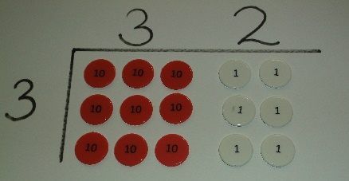  96 ÷ 3  615 ÷ 5  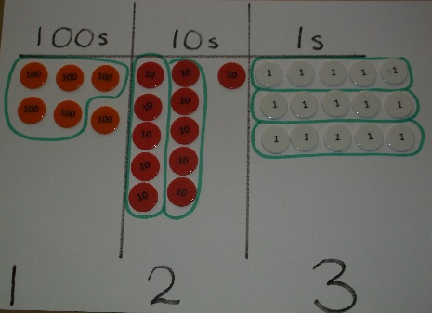  Make the number with place value counters. Start with the biggest place value, put 6 hundreds into groups of 5. Exchange the remaining hundred for 10 tens. Make groups of 5 out of the 11 tens. Exchange the remaining ten for 10 ones. Make groups of 5 with the 15 ones. | 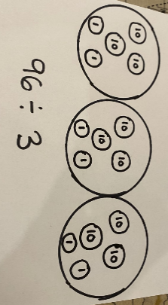  Represent the division pictorially, encouraging them to move towards counting in multiples to divide more efficiently.  Represent the place value counters pictorially  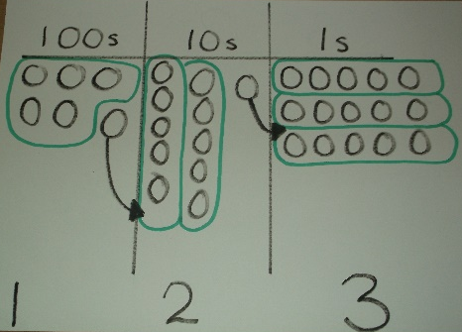 | Complete the calculation using the short division scaffold.  3 2  3 9 6  1 2 3  5 6 ¹1 ¹5
Objective and Strategies | Concrete | Pictorial | Abstract
Short division with remainders and long division | By now, children should be confident with the abstract. They could still use place value counters if needed to provide support.  432 ÷ 5 = 86 r. 2 or 86 2 or 86.4  5  Long division should be taught as a step by step method:  - Divide  - Multiply  - Subtract  - And bring the next digit down  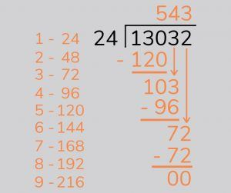  13032 ÷ 24 =  130 ÷ 24  5 x 24 = 120  Subtract and bring the next digit down  103 ÷ 24  4 x 24 = 96  Subtract and bring the next digit down  72 ÷ 24  3 x 24 = 72  No remainder |  | 8 6 r. 2 or 2  5 4 3 ³2 5  8 6 . 4  5 4 3 ³2 . 0  - 30  2 0  2 8 .8  15 4 3 2 .0  3 0  1 3 2  1 2 0  1 2 0  1 2 0  0

